Tool Guide – DNSenum

Introduction
DNSenum is a multithreaded Perl script used for DNS enumeration. It is used to map out target DNS quickly, using a series of checks and brute-force automatically. DNSenum should be used during reconnaissance to gather information about target domains.
Safety Disclaimer: Use only on networks and systems for which you have explicit authorisation. Unauthorized use of tools can be Illegal, unethical and harmful.

Setup and Launch
  - Step1: Open Deakin Detonator Toolkit
- Open Terminal in Linux
- Navigate to your Deakin Detonator Toolkit directory: (cd ~/Deakin-Detonator-Toolkit)
- Run DDT by using the following command line: (yarn run tauri dev)
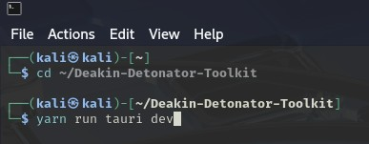
  - Step2: Find Tool-example
- Click on Tools to the left (or use the quick search bar)
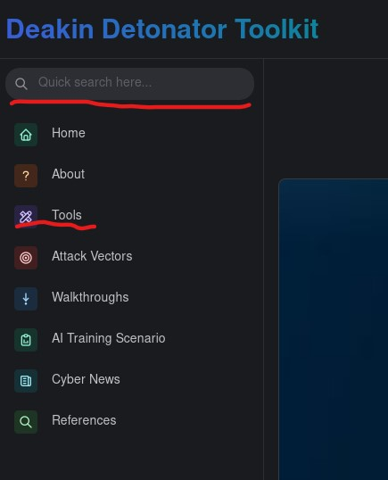
- If you clicked on Tools, scroll down and find DNSenum and click go

Configuration and Usage
  - Step3: Configuring DNSenum
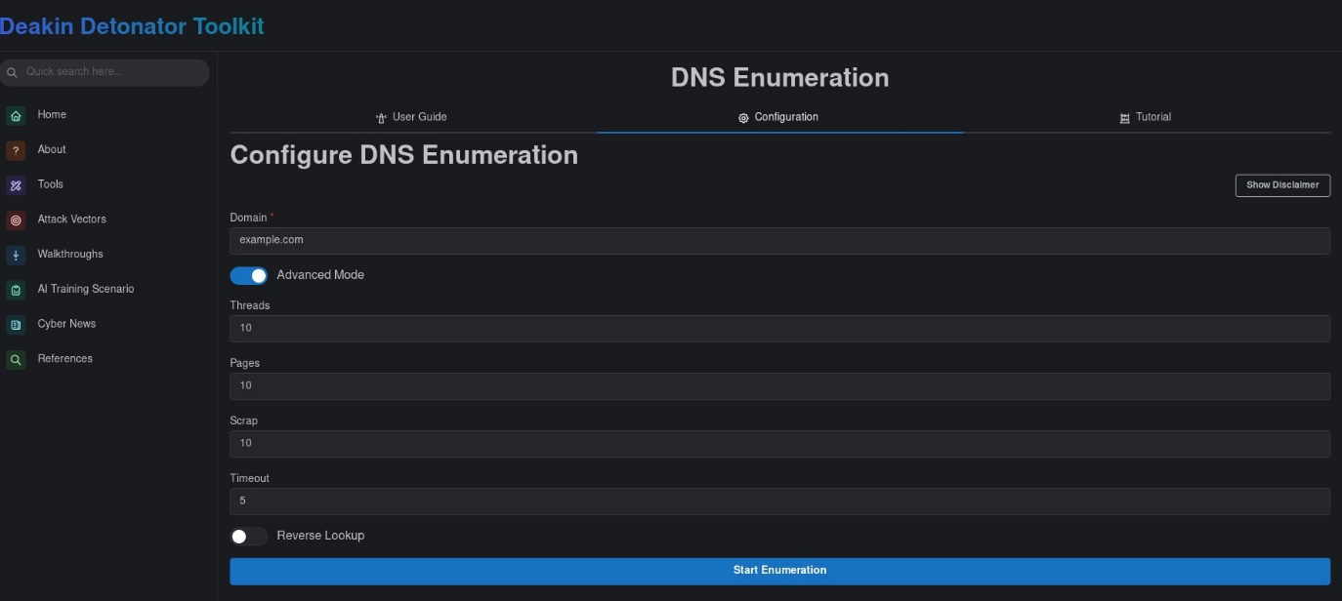
- Enter the domain you wish to use DNSenum on in the Domain Field, e.g. “example.com”.
- You can skip to step 4, or you click advanced mode toggle and continue for advanced mode.
- Options:
Option | Value | Explanation
Threads | Number, e.g. 1 or 2 | Number of parallel tasks DNSenume runs at out, higher is faster but noisier (easier to detect)
Pages | Number, e.g. 1 or 2 | How many pages in a search engine DNSenum should query, more pages will make it slower and sometimes get blocked.
Scrap | Number, e.g. 1 or 2 | Maximum subdomains that will be scraped from google.
Timeout | Number, e.g. 1 or 2 | How long DNSenum should wait before considering a query is dead
Reverse Lookup | toggle | Toggle whether or not DNSenum should perform reverse lookups.

- Click the Start enumeration button when ready.

  - Step4: Results
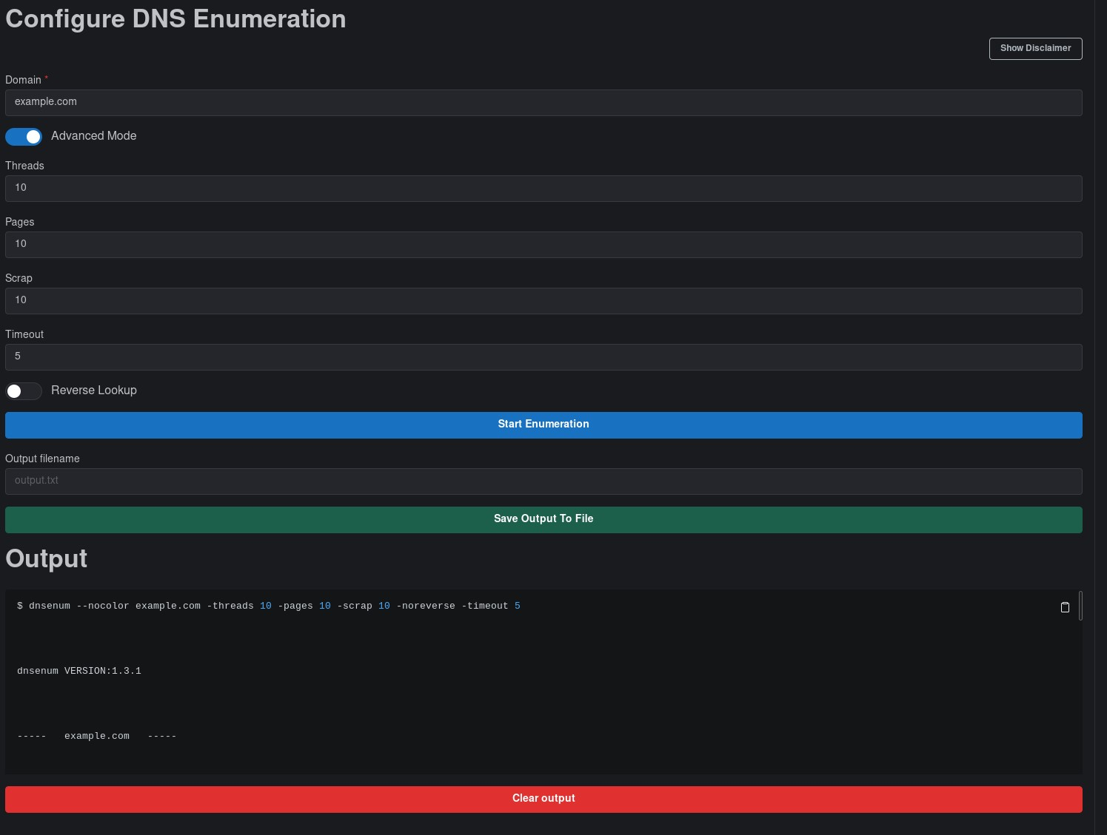
- You will be given an output that should end with “process completed successfully” and be sure to scroll up in the Output field to see the rest.
- Optional: You can save your output by filling out the new “Output filename” field with an appropriate name (output.txt) and then clicking “Save Output To File” button
- Optional: You can copy your output to your clipboard by clicking the little clipboard in the top-right of the output area.

Output Explanation
Note: your output will naturally be dependent on what domain you used and your settings, the following is non-comprehensive example output of what you could get from using DNSenum on domain “example.com”, with threads 5, pages 2, scrap 2, timeout 5.
- $ dnsenum --nocolor example.com -threads 5 -pages 2 -scrap 2 -timeout 5
  - The command used
  - –nocolor removes coloured output
  - -threads 5, run 5 dns queries in parallel
  - -pages 2, only scrape 2 pages of google results
  - -scrap 2, only perform 2 google scrape attempts with different queries
  - -timeout 5, wait max 5 seconds for each DNS reply before skipping.
- example.com. 118 IN A 23.220.75.232
  - an example of an A record, an IPv4 address linked to a domain
- a.iana-servers.net. 157 IN A 199.43.135.53
  - an example of a Name server record.
- Trying Zone Transfer for example.com on a.iana-servers.net ...
AXFR record query failed: REFUSED
  - An attempt at getting a full DNS zone copy, typically refused.

